 | Limited Liability Company  "UNDERWATER TECHNICAL EXPERT"LTD.  Address: Apt. 1, 80 Novorossiyskoy Respubliki St., Novorossiysk, Krasnodar Territory, 353900, Russia  INN (Taxpayer ID): 2315243770  KPP (Tax Registration Reason Code): 231501001  OGRN (Primary State Registration Number): 1262300014206  Dispatcher Tel: +7 900 272 85 51  E-mail: aquatechexpert@mail.ru
From: LLC "PODVODNY TEKHNICHESKY EKSPERT" (UNDERWATER TECHNICAL EXPERT), diving company
To: Master of m/v«{{vessel_name}}»
CC: Agents
Date: of underwater inspection {{diving_date}}, Port: Novorossiysk
Dear Master,
We would like to inform you that commencement of underwater inspection of m/v {{vessel_name}} is expected on {{diving_date}} since 07:30 till 17:00 depends on weather conditions and port authorities permission. We kindly ask You to provide us with the following information:
- General arrangement plan with hull’s detailed drawing;
- The specifications of current cathodic protection system.
We will kindly ask you to stop the work of scrubbers for 5 minutes while divers observing the stern of the ship (if possible).
Prior to commencement of the underwater diving inspection – the pre-diving check list (which is attached to an email containing also this Letter) to be signed, stamped and provided to: vessel, Agent, Harbor Master and Diver – each party with one original. Information stated in pre-diving check list is to be acknowledged and vessel’s administration should act accordingly.
Upon completion of the underwater diving inspection, You will be provided with originals of all necessary stamped and signed documents from the diving team leader at vessel’s side.
Also, as the need for the inspection, please advise whether any constructional changes/modifications were applied to Your vessel’s hull including its underwater part with all mechanisms and auxiliary devices. In case such changes are made - please provide us with corresponding information in remarks below (photos, in case same are available to be attached to Your reply email).
If not - then we kindly ask You to add the following wording in remarks below: “no modifications and/or changes were made/applied” and send us back scan-copy of this Letter via email prior to commencement of inspection.
All abovementioned, including documents, is the need for our diving team to be fully aware of possible findings that they may consider suspicious during underwater inspection.
PLEASE, UPON RECEIPT OF THIS LETTER PUT YOUR STAMP AND SIGNATURE
________________________________________________________________________________________________________________________________________________________________________________________________________________________________________________________________________________________________________________________________________________________________________
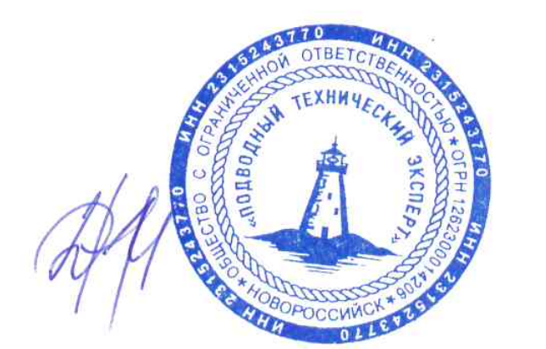
General Director  "UNDERWATER TECHNICAL EXPERT" LTD.  Nikitchenko D.I. | Acknowledged by Master of  m/v “{{vessel_name}}”

